**NATURAL LANGUAGE PROCESSING**

**TASK 2**

**DATE – 06/12/19**

**TAVISH TEVATIA**

**17BCE2029**

**KEYWORD – “RONALDO**”

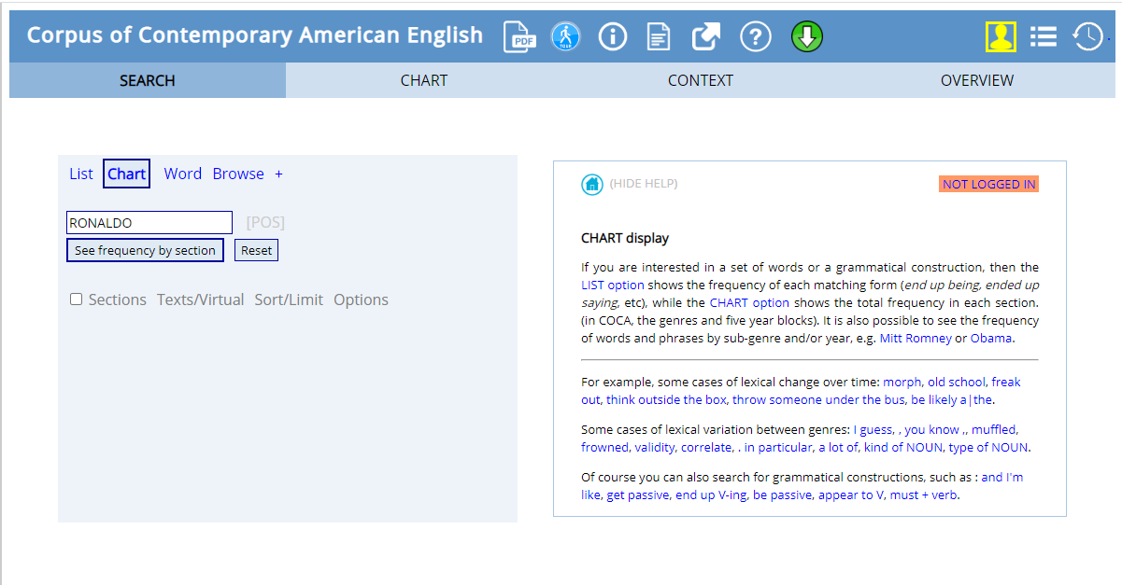

**CHART**

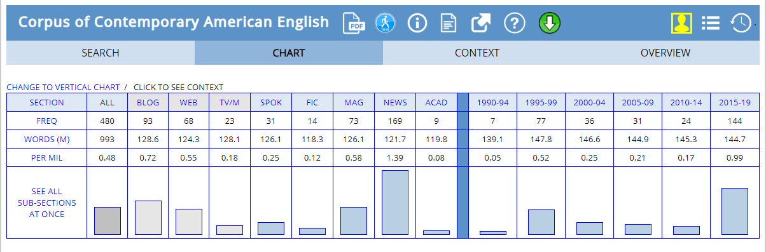

* The number **of hits** on the word RONALDO **– 480**
* The mode of media through which the term was spread **the most** was – **BLOG**
* And the time period of **most frequency** is **1995-1999 & 2015-2019.**